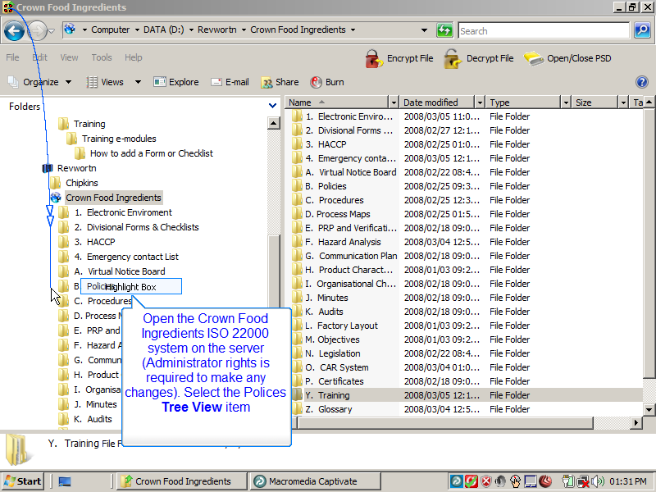
Slide 1
Note:
Open the Crown Food Ingredients ISO 22000 system on the server (Administrator rights is required to make any changes). Select the Polices Tree View item

Notes:

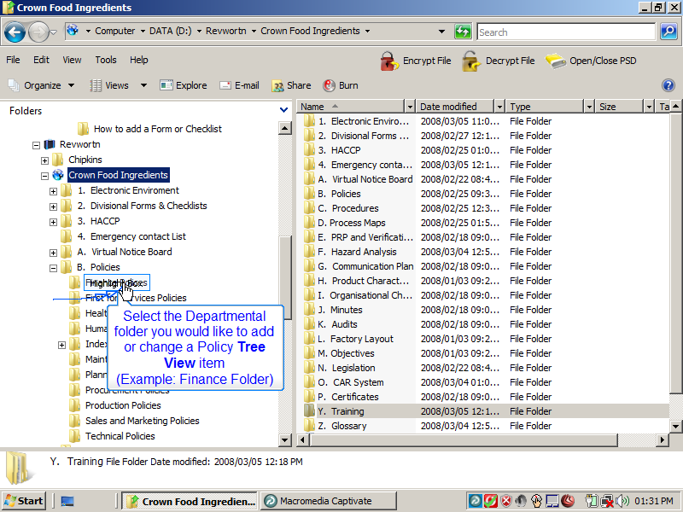
Slide 2
Note:
Select the Departmental folder you would like to add or change a Policy Tree View item
(Example: Finance Folder)
Notes:

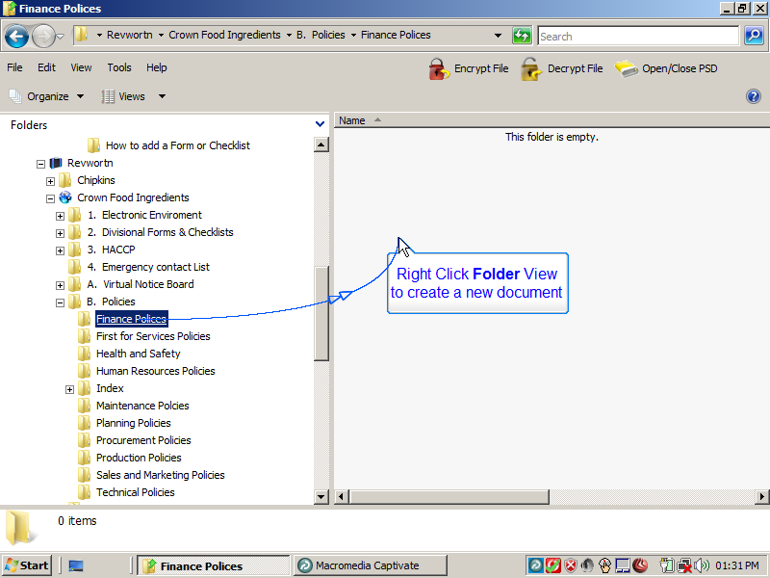
Slide 3
Note:
Right Click Folder View to create a new document
Notes:

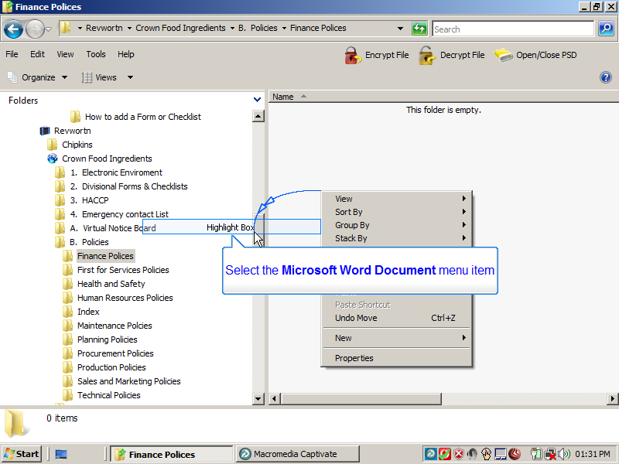
Slide 4
Note:
Select the Microsoft Word Document menu item
Notes:

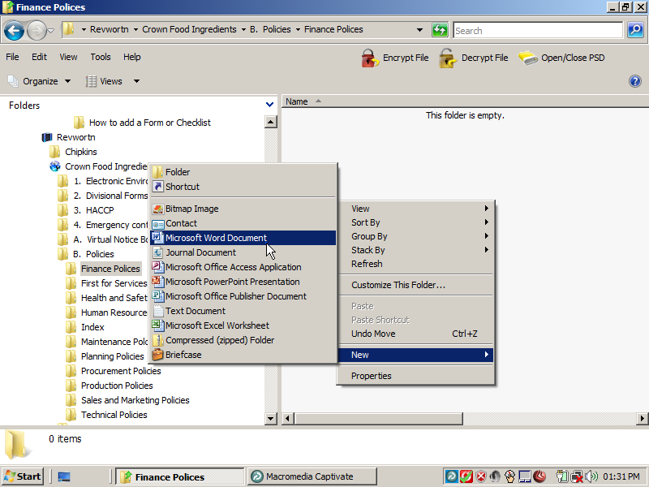
Slide 5
Note:
Notes:

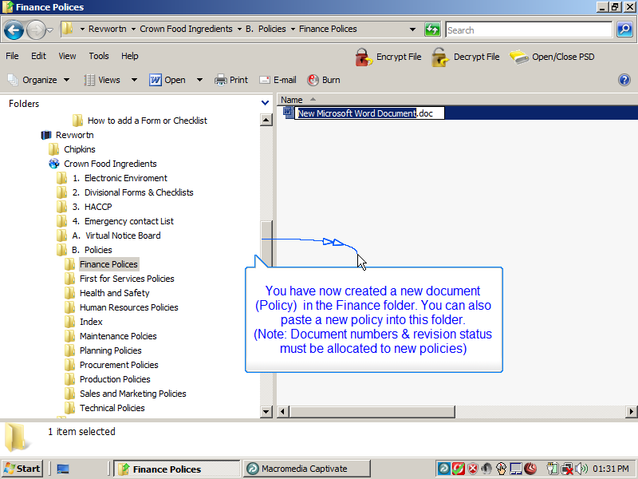
Slide 6
Note:
You have now created a new document (Policy) in the Finance folder. You can also paste a new policy into this folder.
(Note: Document numbers & revision status must be allocated to new policies)
Notes:

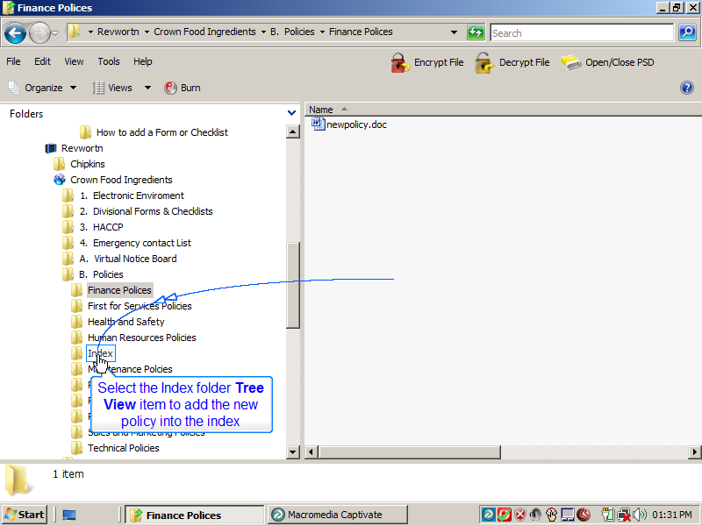
Slide 7
Note:
Select the Index folder Tree View item to add the new policy into the index
Notes:

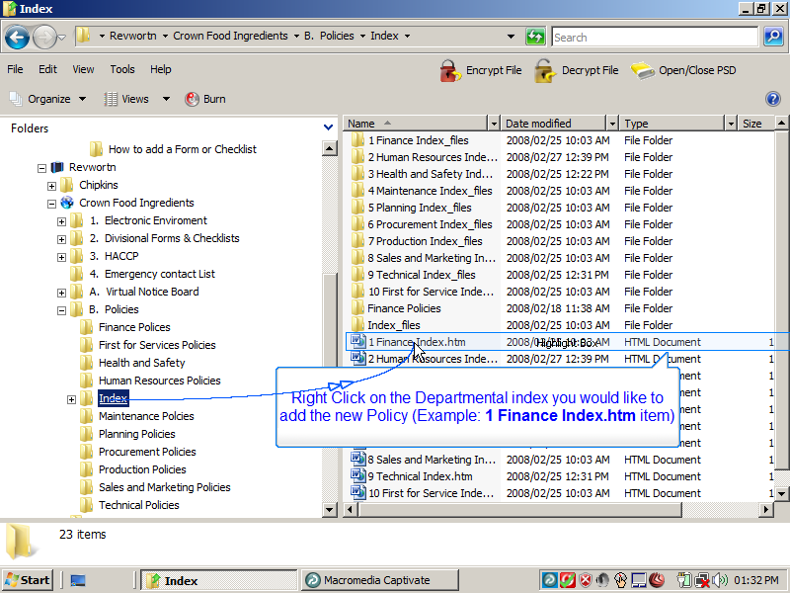
Slide 8
Note:
Right Click on the Departmental index you would like to add the new Policy (Example: 1 Finance Index.htm item)
Notes:

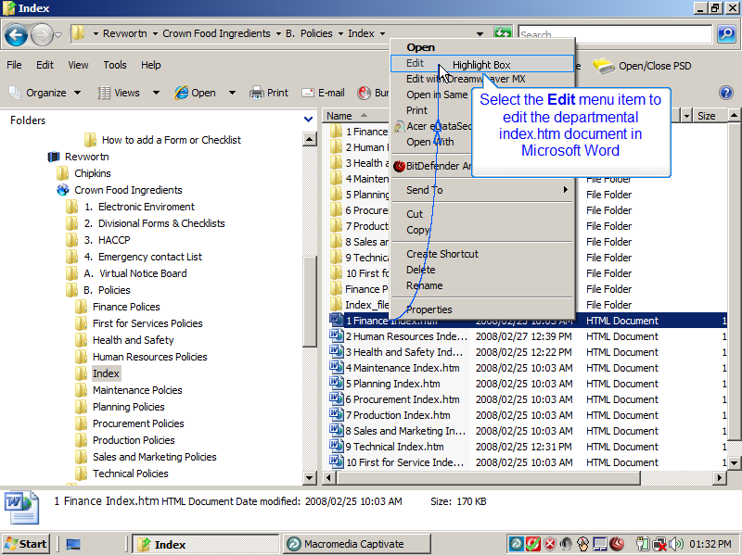
Slide 9
Note:
Select the Edit menu item to edit the departmental index.htm document in Microsoft Word

Notes:

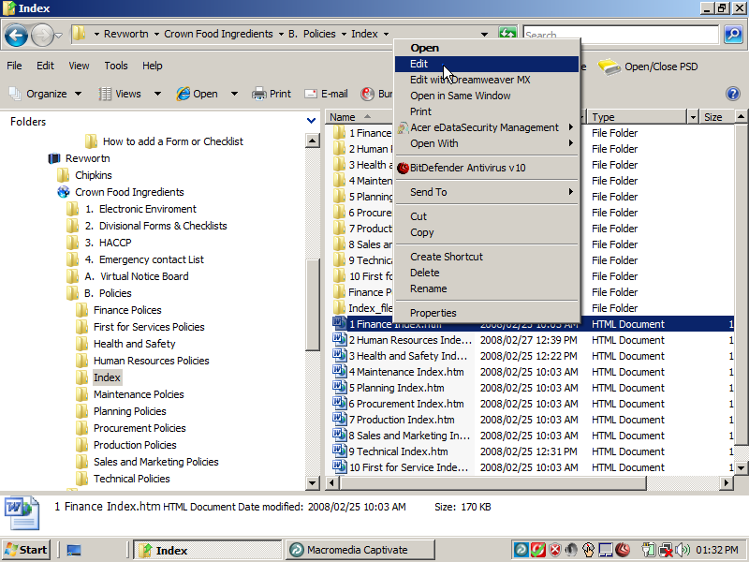
Slide 10
Note:
Notes:

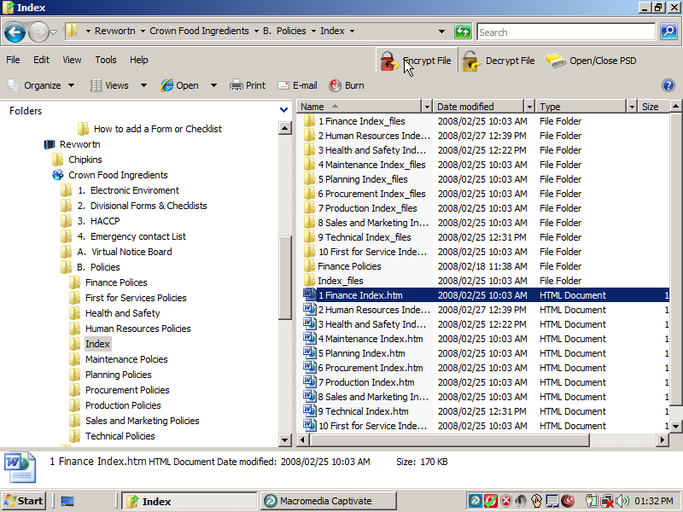
Slide 11
Note:
Notes:

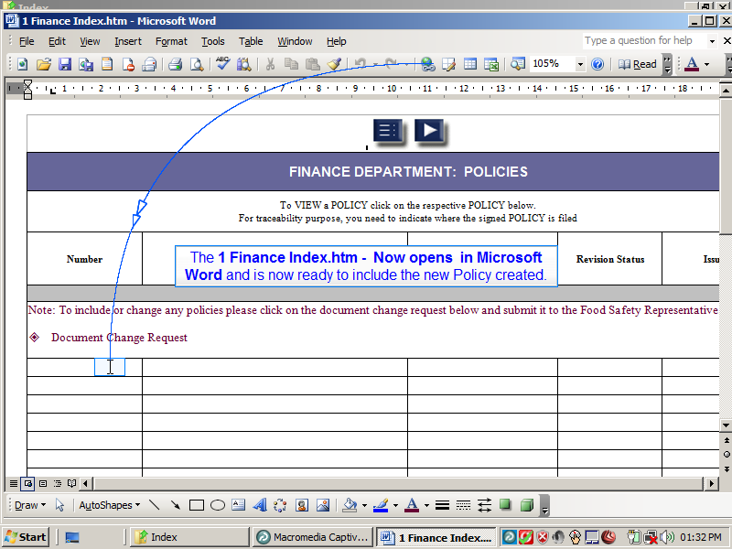
Slide 12
Note:
The 1 Finance Index.htm - Now opens in Microsoft Word and is now ready to include the new Policy created.
Notes:

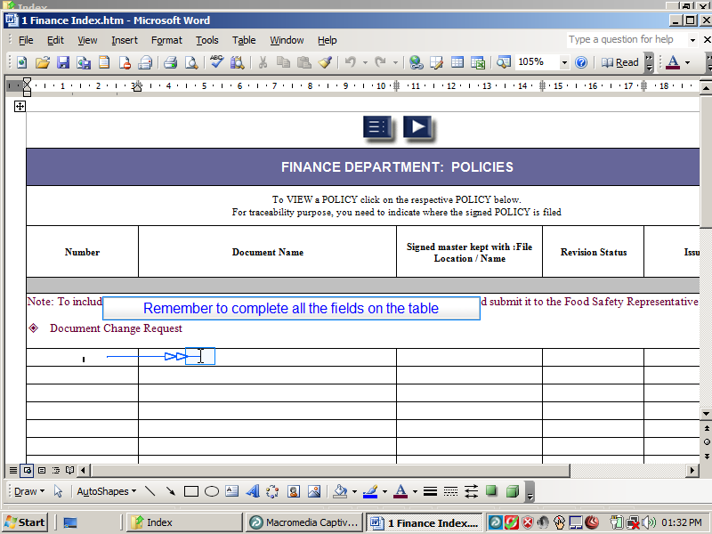
Slide 13
Note:
Remember to complete all the fields on the table
Notes:

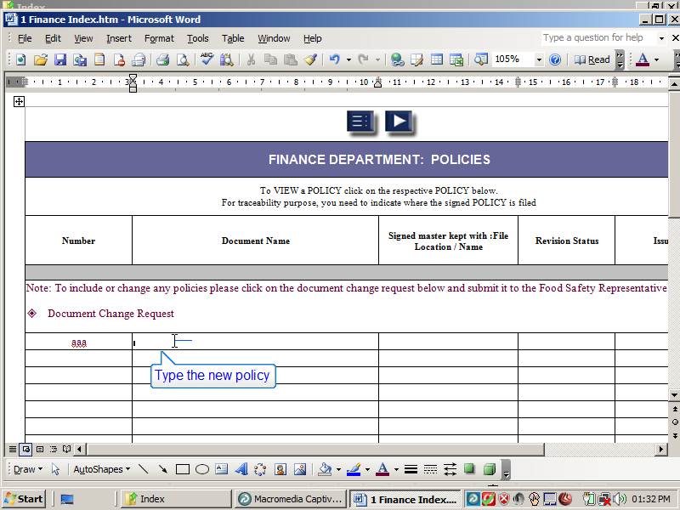
Slide 14
Note:
Type the new policy Name
Notes:

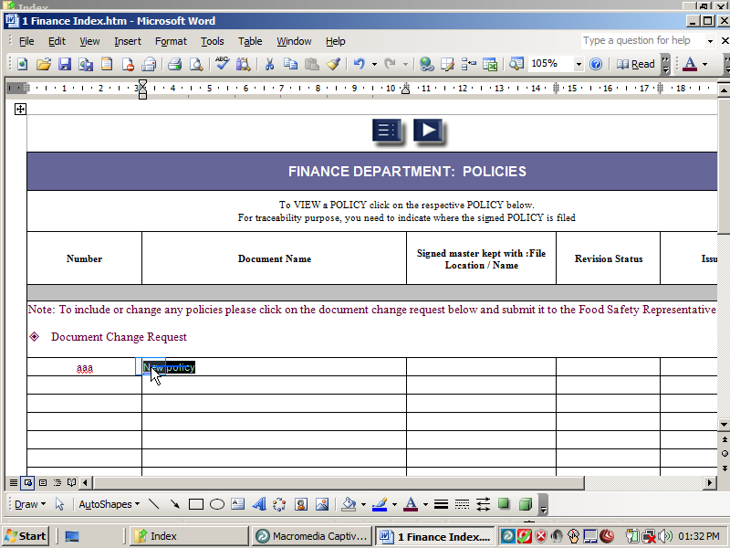
Slide 15
Note:
Notes:

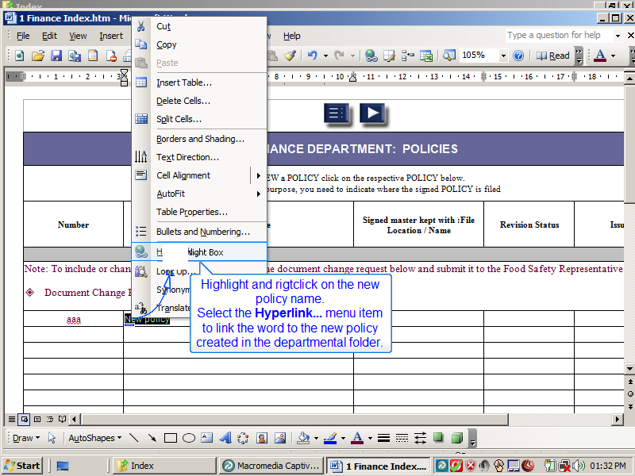
Slide 16
Note:
Highlight and rigtclick on the new policy name.
Select the Hyperlink... menu item to link the word to the new policy created in the departmental folder.
Notes:

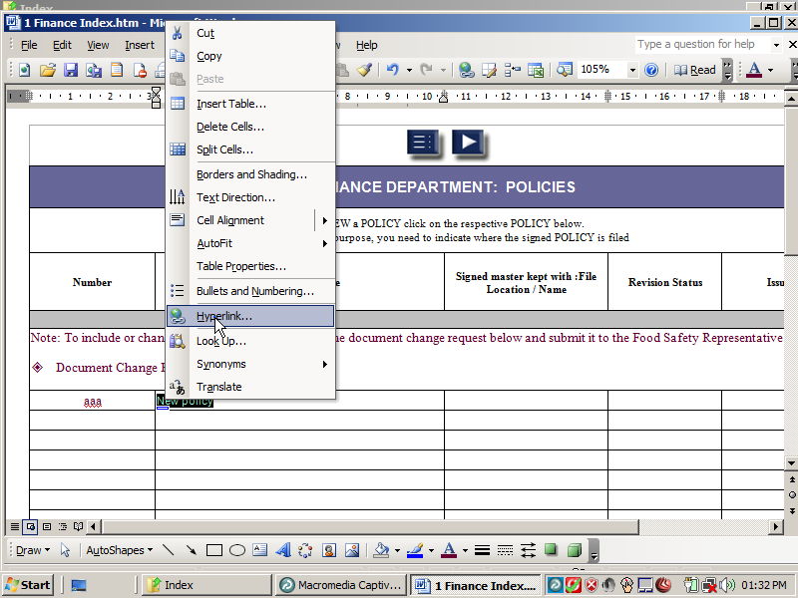
Slide 17
Note:
Notes:

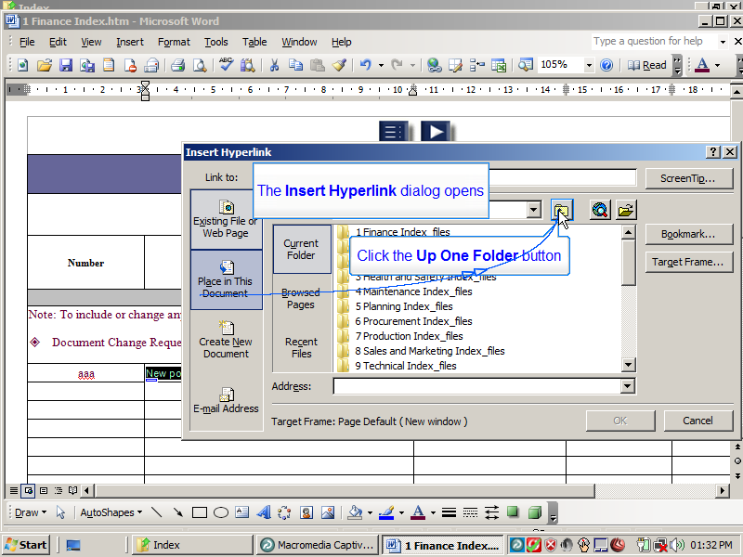
Slide 18
Note:
The Insert Hyperlink dialog opens
Click the Up One Folder button
Notes:

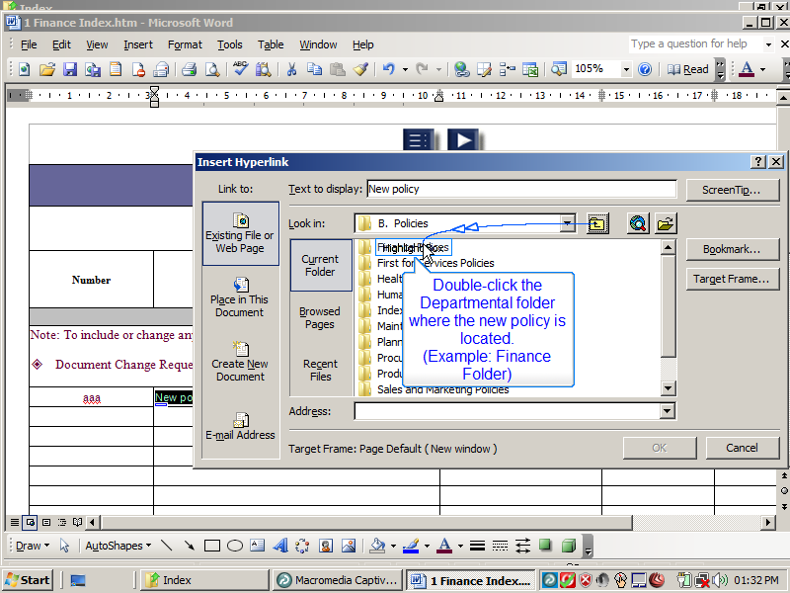
Slide 19
Note:
Double-click the Departmental folder where the new policy is located.
(Example: Finance Folder)
Notes:

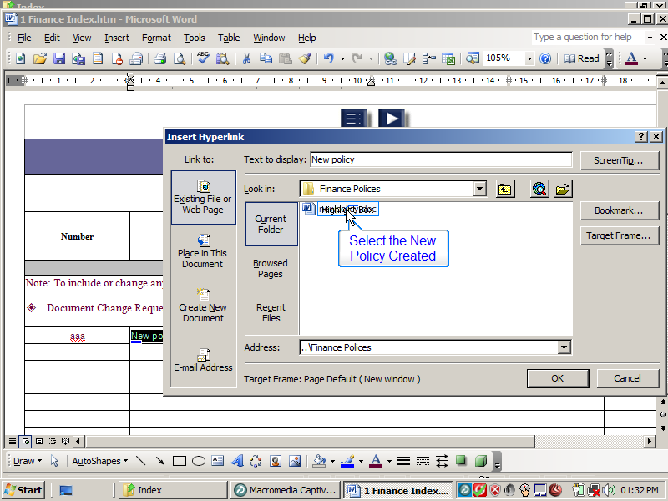
Slide 20
Note:
Select the New Policy Created
Notes:

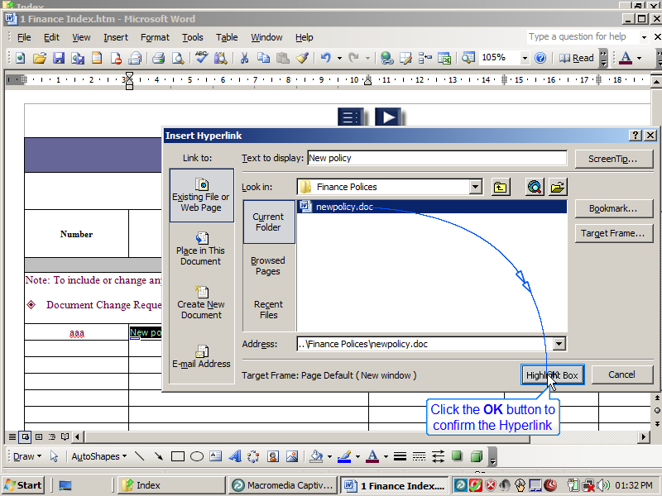
Slide 21
Note:
Click the OK button to confirm the Hyperlink
Notes:

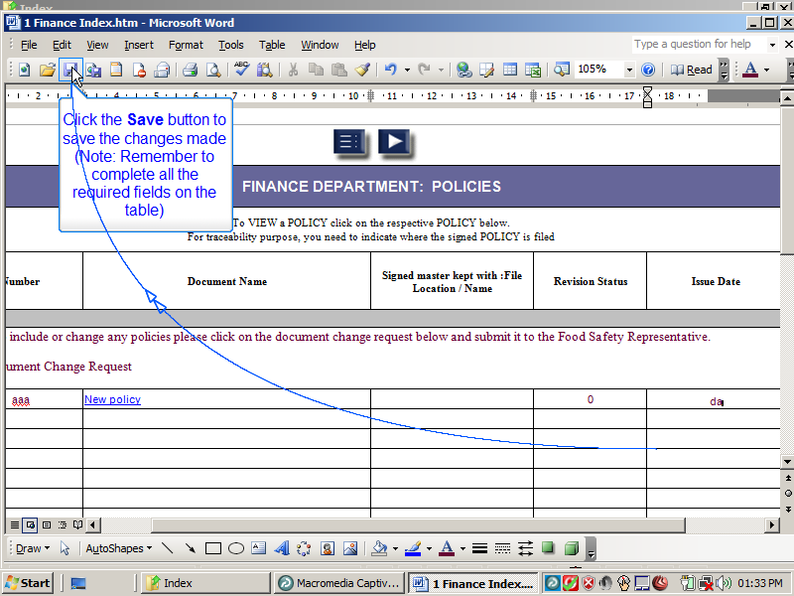
Slide 22
Note:
Click the Save button to save the changes made
(Note: Remember to complete all the required fields on the table)
Notes:

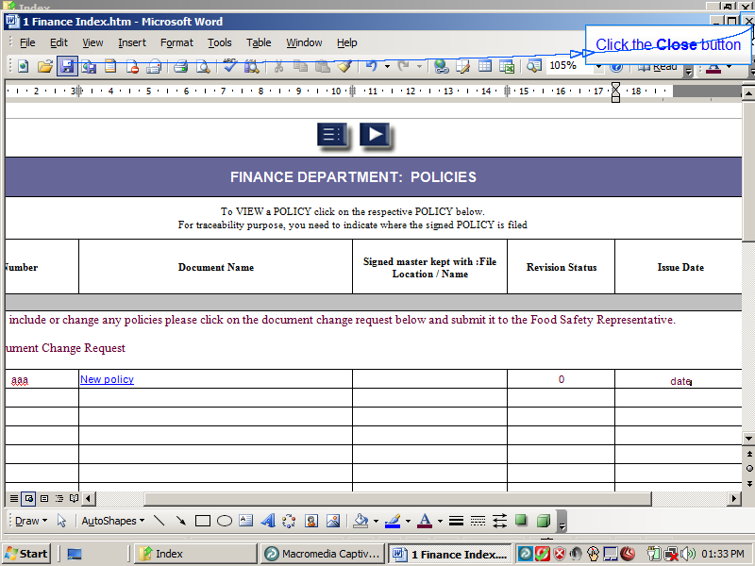
Slide 23
Note:
Click the Close button
Notes:

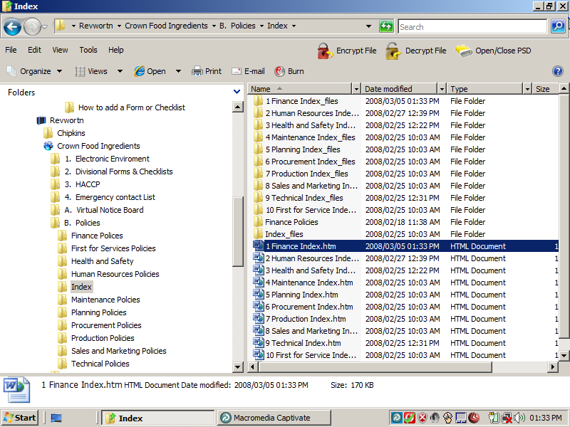
Slide 24
Note:
Notes:

